## KAFKA For Begining

### Kafka architecture

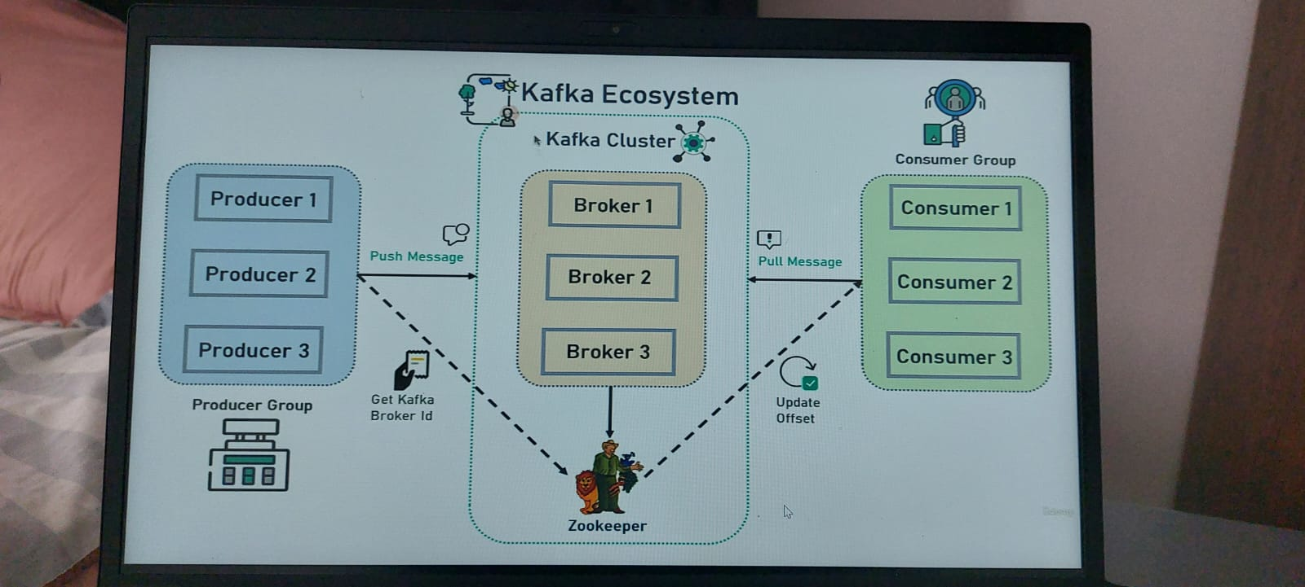

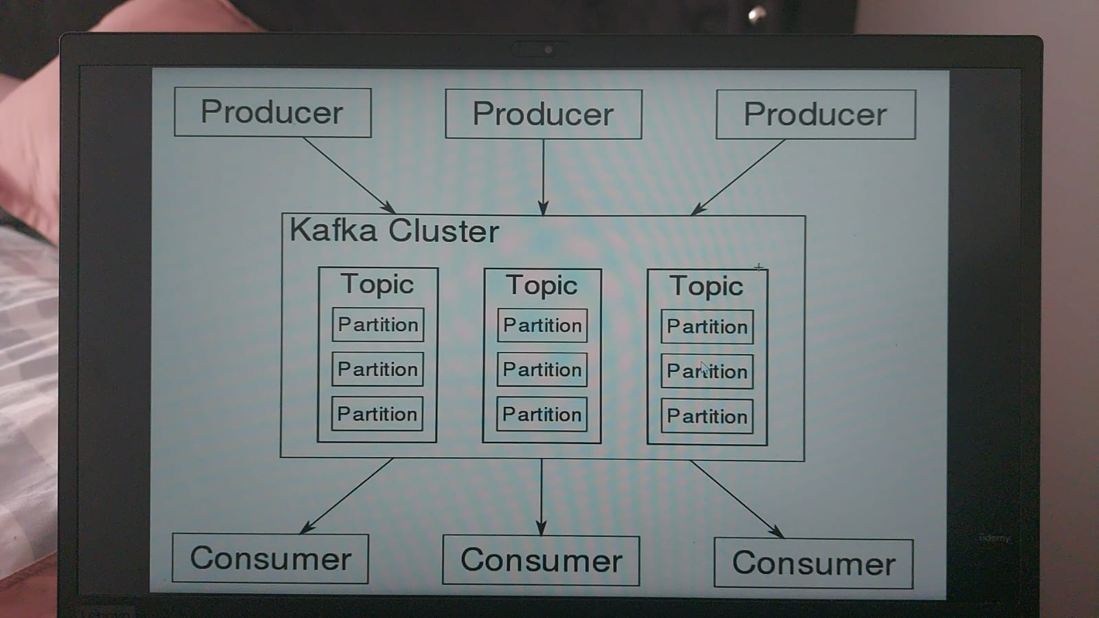

### Concepts

1. Kafka cluster: a set of brokers, mininum 3 brokers.

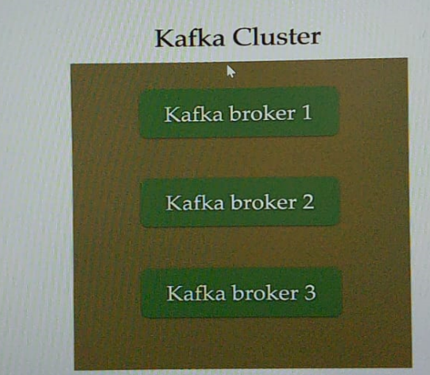

1. The Broker is the kafka server. Just the name giving to the kafka server. Producer and consumer use a broker to exchange messages.

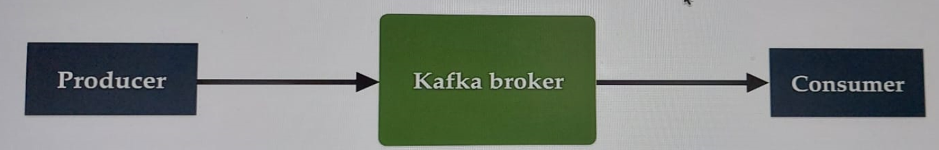

1. Producer: is an application that sends messages. Not directly to consumer but via a broker(kafka server).



1. Consumer is an application that reads message from kafka server(broker). Any application that requests data from a kafka server is a consumer.



1. Kafka Topic: is like a table in database or folder in a file system. It is identified by name. We can have any number of topics.

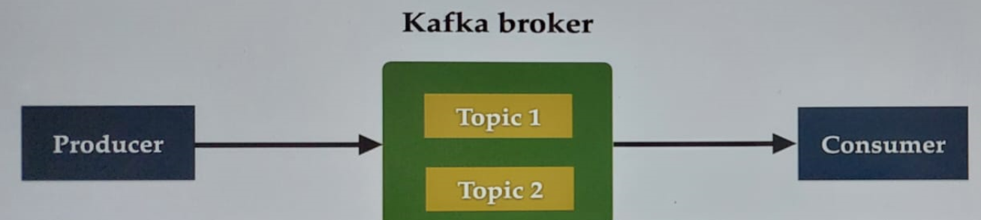

1. Kafka Partitions: Kafka topics are divided into a number of partitions which contain records (large data).

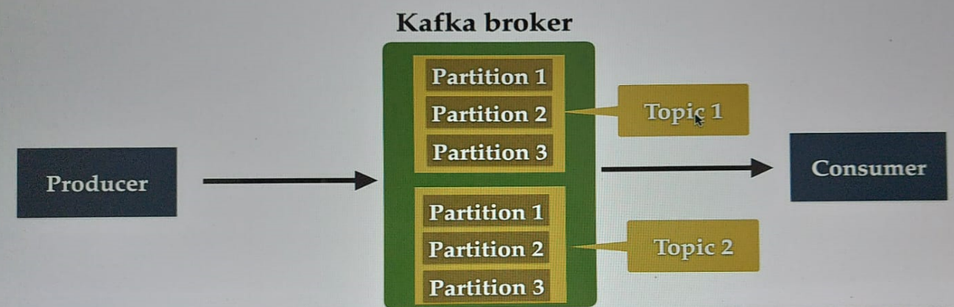

1. Offset is a sequence of ids given to messages as the arrive at a partition. Once the offset is assigned it will never be changed. The first message gets an offset zero, next message offset one,…

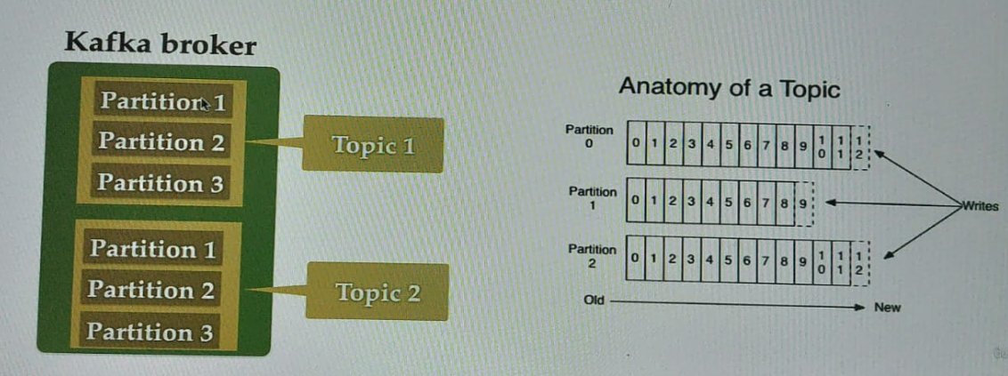

1. Consumer Groups: Contains one or more consumes working together to process the messages.

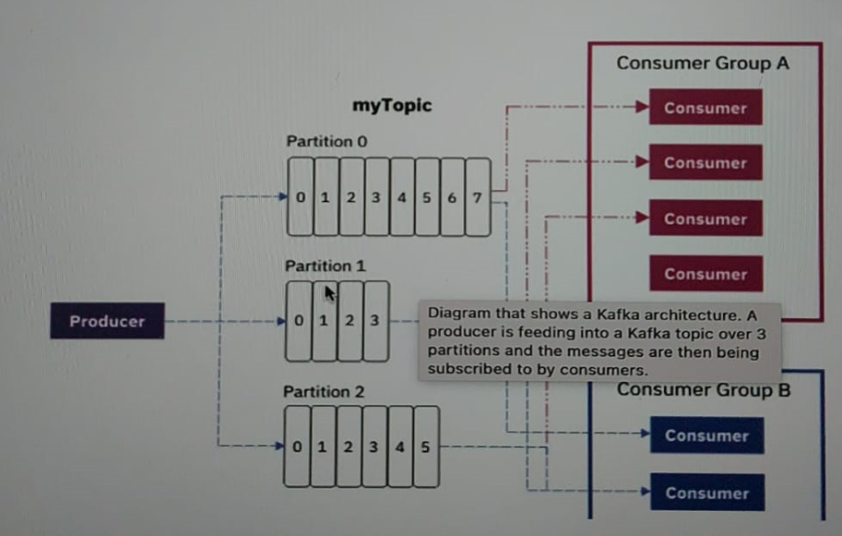

1. Zookeeper: is a service that manage all the stage of kafka cluster, kafka broker, topic,

### Install and setup

Download apache kafka here <https://kafka.apache.org/quickstart> and follow the steps. Start zookeeper-server and kafka-server.

* Command to execute zookeeper server on windows: .\bin\windows\zookeeper-server-start.bat .\config\zookeeper.properties

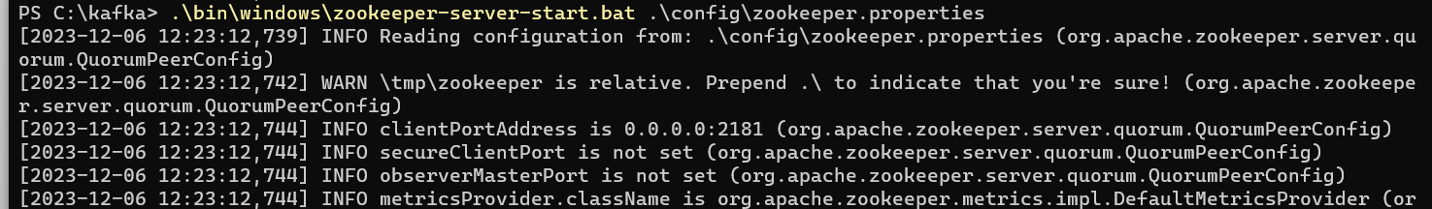

* Command to execute kafka server on windows: .\bin\windows\kafka-server-start.bat .\config\server.properties

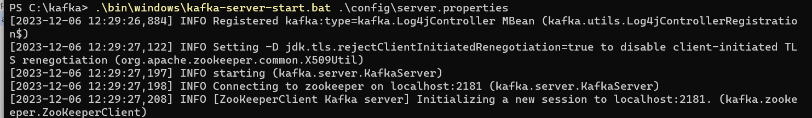

### Create and setup a spring boot project in intellij

Your can use this link <https://start.spring.io/>

Make sure to add the spring-boot kafka maven/gradle dependency

<https://docs.spring.io/spring-kafka/reference/quick-tour.html>

### Configure Kafka Producer and Consumer

Configure your application.yml like this

spring:  
 kafka:  
 producer:  
 bootstrap-servers: localhost:9092  
 key-serializer: org.apache.kafka.common.serialization.StringSerializer  
 value-serializer: org.apache.kafka.common.serialization.StringSerializer  
  
 consumer:  
 bootstrap-servers: localhost:9092  
 group-id: myGroup  
 auto-offset-reset: earliest  
 key-deserializer: org.apache.kafka.common.serialization.StringDeserializer  
 value-deserializer: org.apache.kafka.common.serialization.StringDeserializer

### Create kafka topic

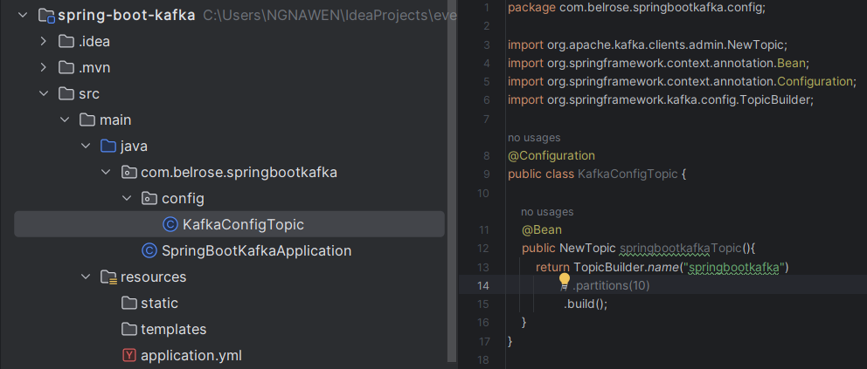

### Create kafka Producer

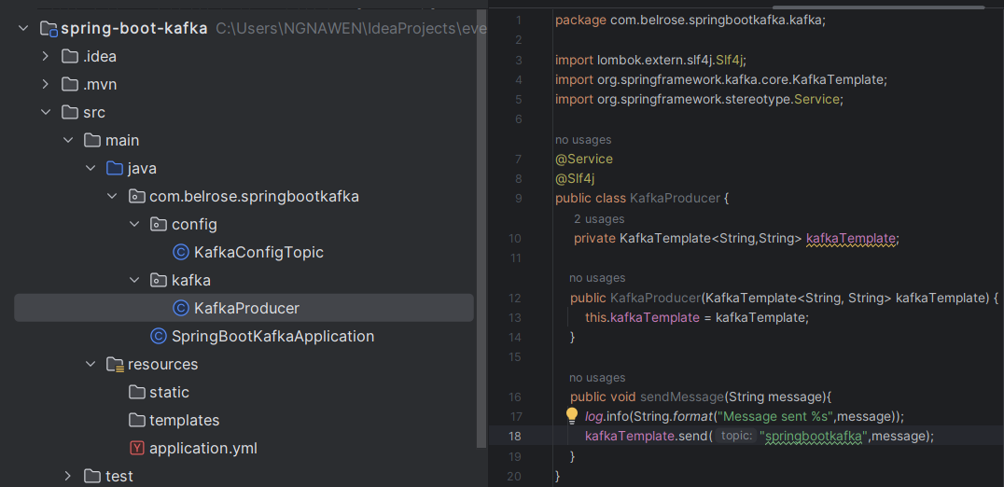

Create REST API to Send Message

Based on the Kafka architecture, The REST API will send message to producer and then the producer will send it to kafka broker.

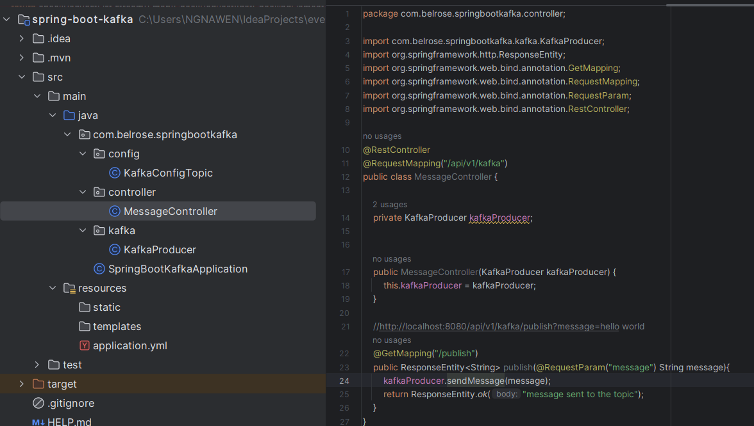

Read the events/message in the console

Execute this command in the terminal:

.\bin\windows\kafka-console-consumer.bat --topic springbootkafka --from-beginning --bootstrap-server localhost:9092

Request sent:

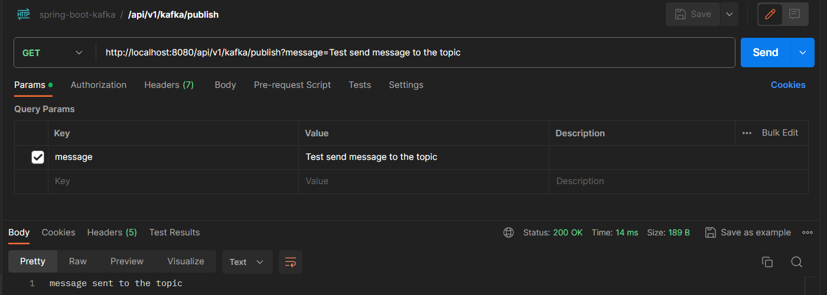

Response:



### Create kafka Consumer

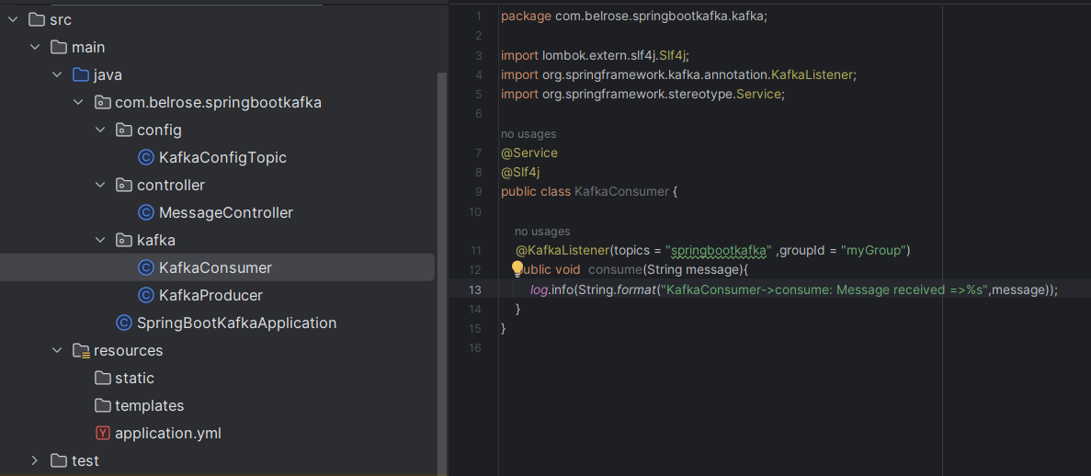

### Configure kafka Producer and Consumer for JSON Serializer and Deserializer

spring:  
 kafka:  
 producer:  
 bootstrap-servers: localhost:9092  
 key-serializer: org.apache.kafka.common.serialization.StringSerializer  
 *#value-serializer: org.apache.kafka.common.serialization.StringSerializer* value-serializer: org.springframework.kafka.support.serializer.JsonSerializer  
  
 consumer:  
 bootstrap-servers: localhost:9092  
 group-id: myGroup  
 auto-offset-reset: earliest  
 key-deserializer: org.apache.kafka.common.serialization.StringDeserializer  
 *#value-deserializer: org.apache.kafka.common.serialization.StringDeserializer* value-deserializer: org.springframework.kafka.support.serializer.JsonDeserializer  
 properties:  
 spring:  
 json:  
 trusted:  
 packages: '*'

### Create a simple POJO to Serializer and Deserializer

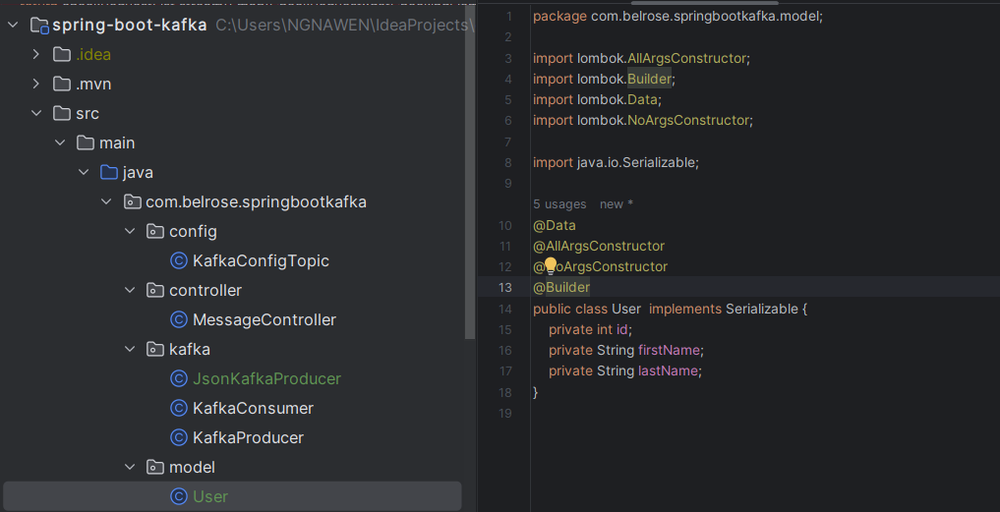

### Create kafka producer to produce JSON message

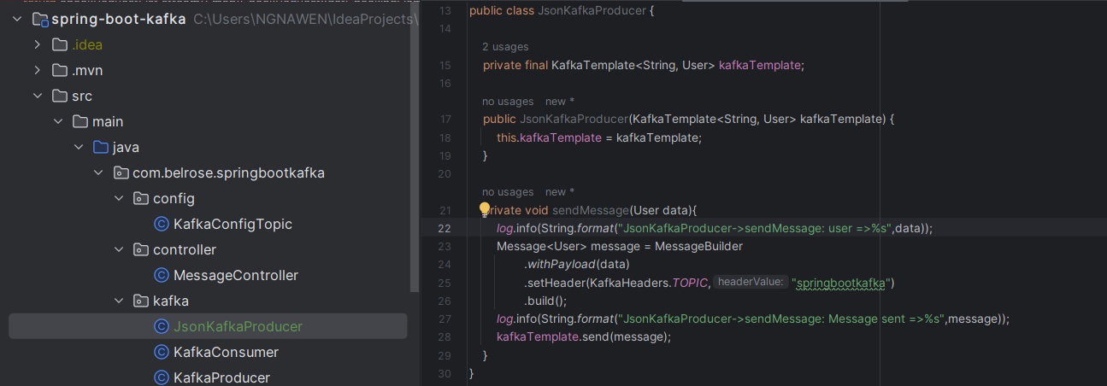

### Create REST API to send JSON Object

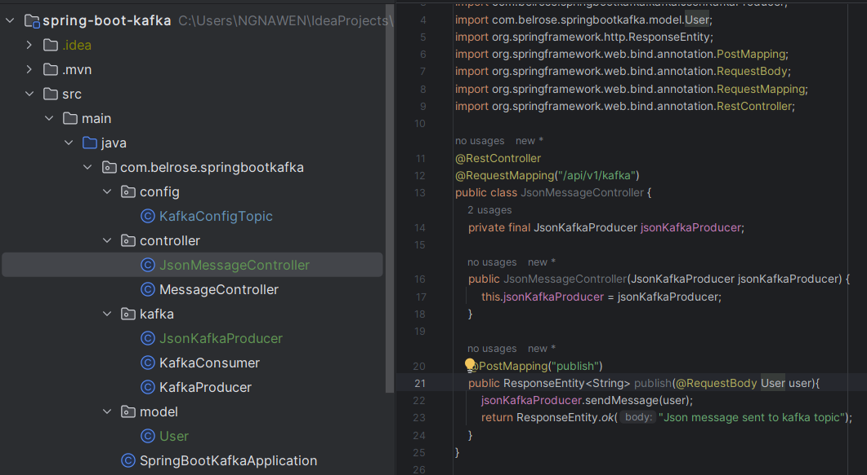

### Create kafka Consumer to consume JSON message

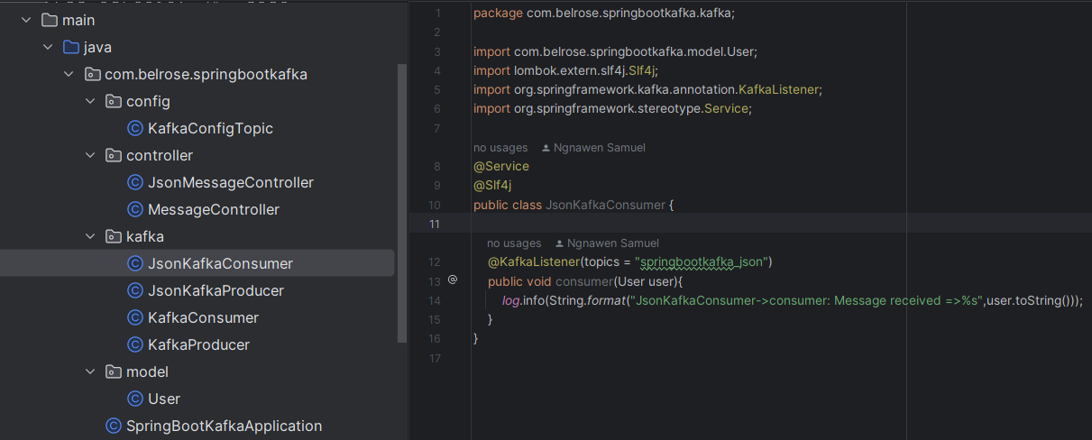

## KAFKA in the real project

### Context

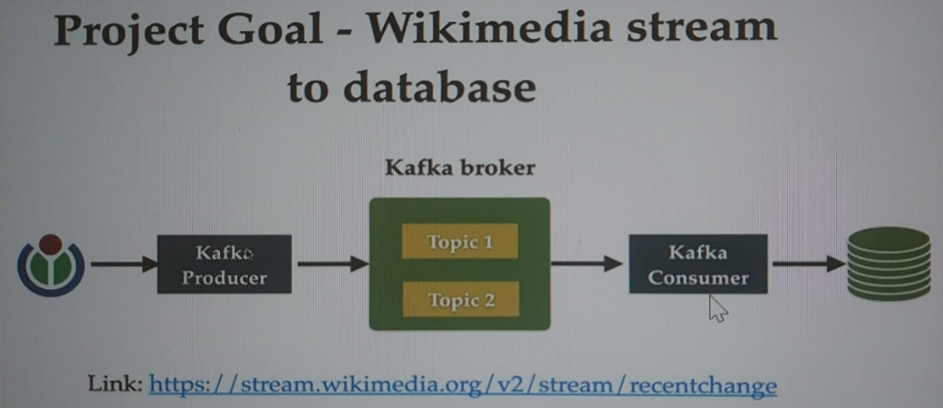

<https://esjewett.github.io/wm-eventsource-demo/>

<https://codepen.io/Krinkle/pen/BwEKgW>

<https://stream.wikimedia.org/?doc#/streams>

### Spring boot kafka project setup

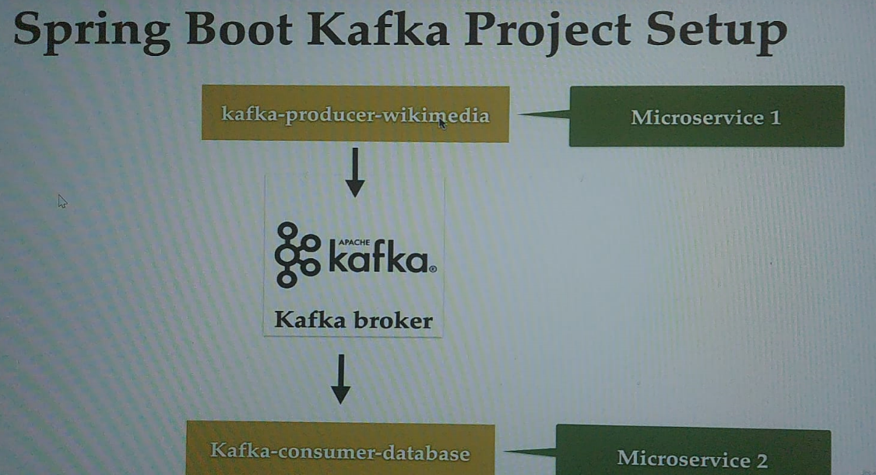

Create a spring boot project in <https://start.spring.io/> and added this tag <packaging>pom</packaging> to set the project as multi modules project. Right clic on that project and create the modules. Add this tag <packaging>jar</packaging> within the pom.xml module project

### Configure Wikimedia producer and create a topic

### Wikimedia kafka producer implementation

### Kafka consumer Spring boot project setup

### Configure kafka consumer in application.yml file

### Configure Mysql database in the application.yml file

### Save Wikimedia Data into MySQL Database

## Event-driven microservices architecture (EDMA)

It is the architecture where the applications communicate with each other by sending and/or receiving events or messages. It is a programming approach, not a language.

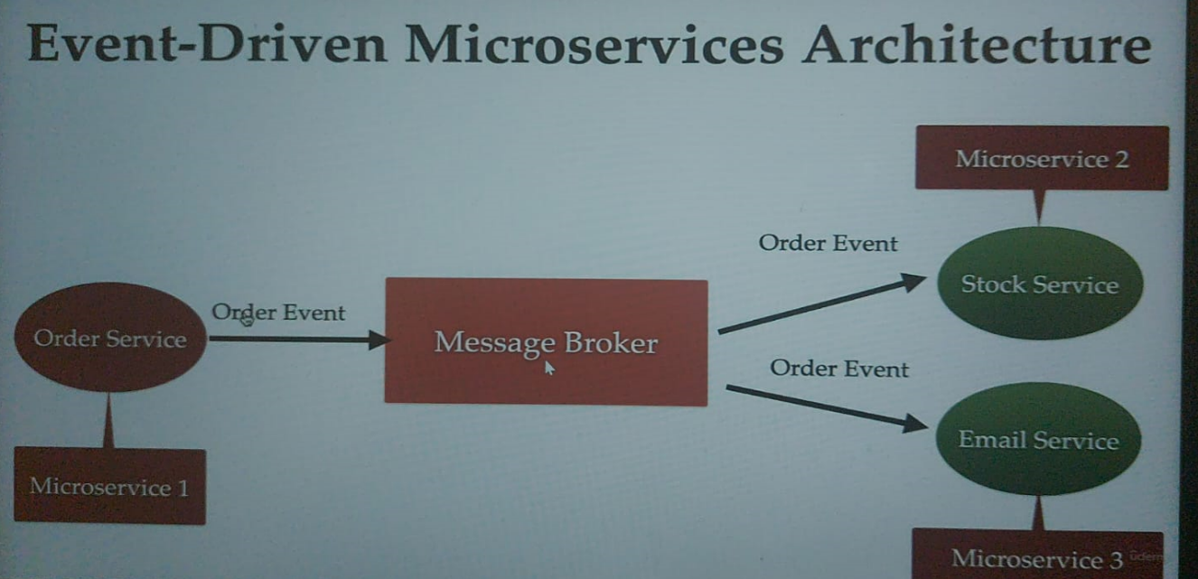

Advantages of EDMA:

* Improves flexibility and maintainability
* High scalability
* Improved availability (if one microservice go down, it won’t impacted other microservices)

### Spring boot kafka Event-Driven Microservices Architecture with Multipe Consumers

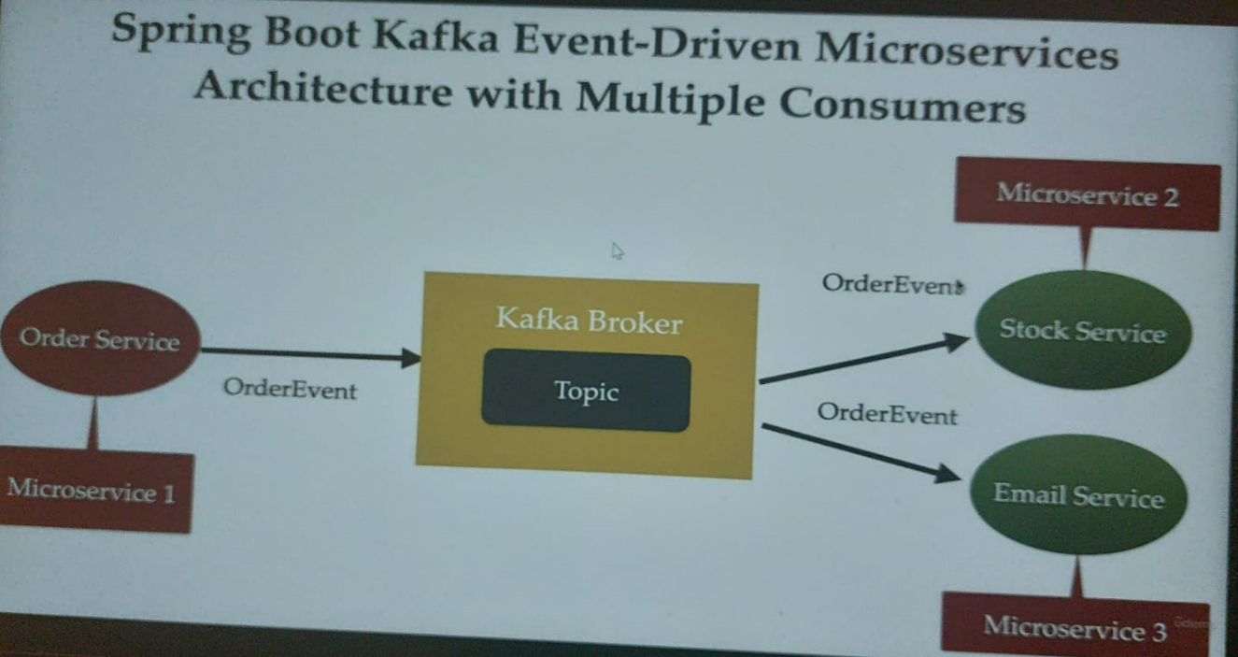

## RabbitMQ For Begining

### Concepts

1. Queue: is buffer or storage in a RabbitMQ broker to store messages.
2. Message: Information that is send from the producer to a consumer though RabbitMQ.
3. Exchange: it acts as an intermediary between the producer and a queue.

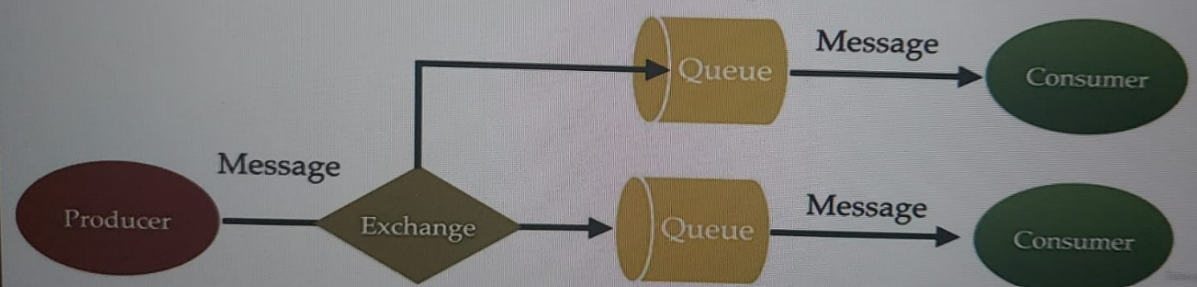

1. Routing key: (Binding did here)

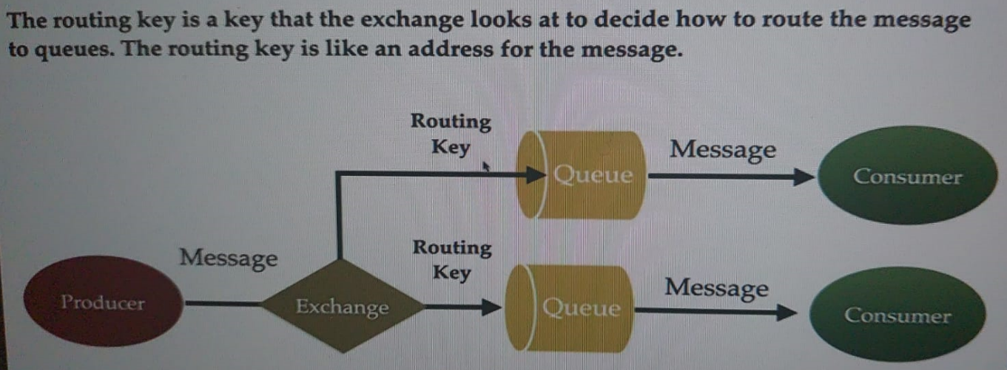

1. Message queue: allow application to communicate by sending messages to each other.

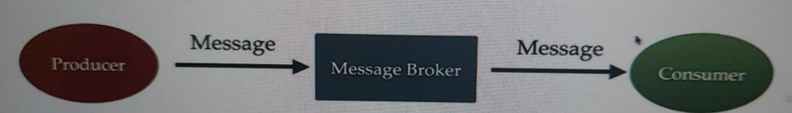

1. RabbitMQ : is a message queue software (message broker/queue manager) that acts as an intermediary platform where different applications can send and receive messages

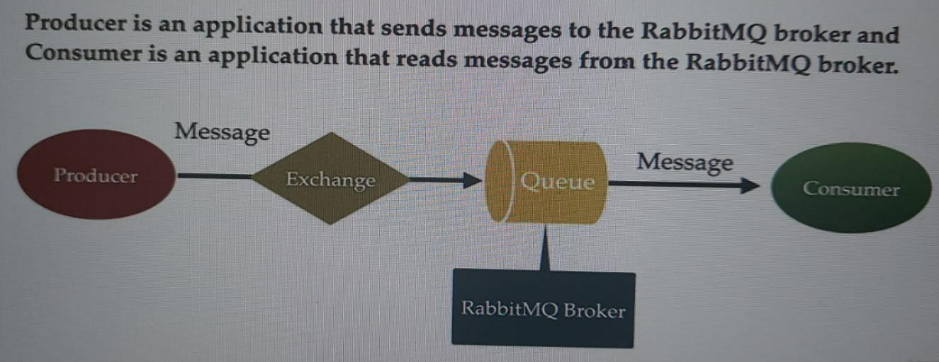

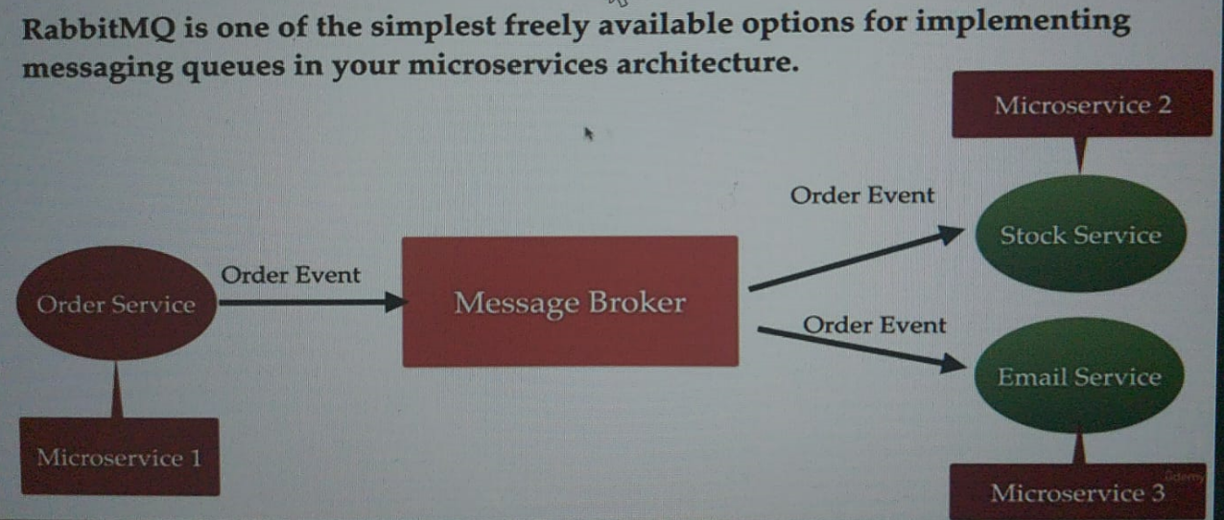

### Install RabbitMQ using docker and configure it

1. Install and open docker desktop on your local machine
2. Open docker hub and search RabbitMQ (<https://hub.docker.com/_/rabbitmq>), copy 3.12.10-management tag
3. Open your terminal use doker pull rabbitmq:3.12.10-management to pull rbbitmq to your docker desktop

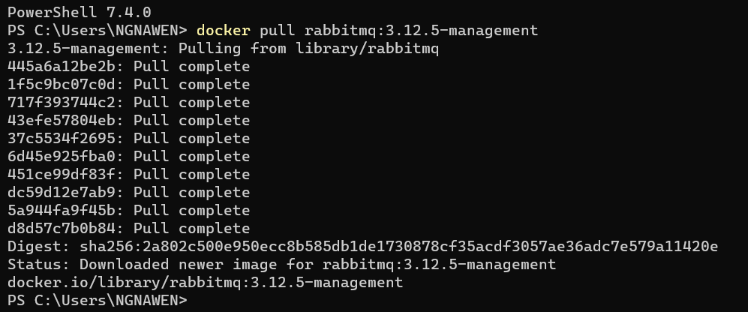

1. Go to your docker desktop and see

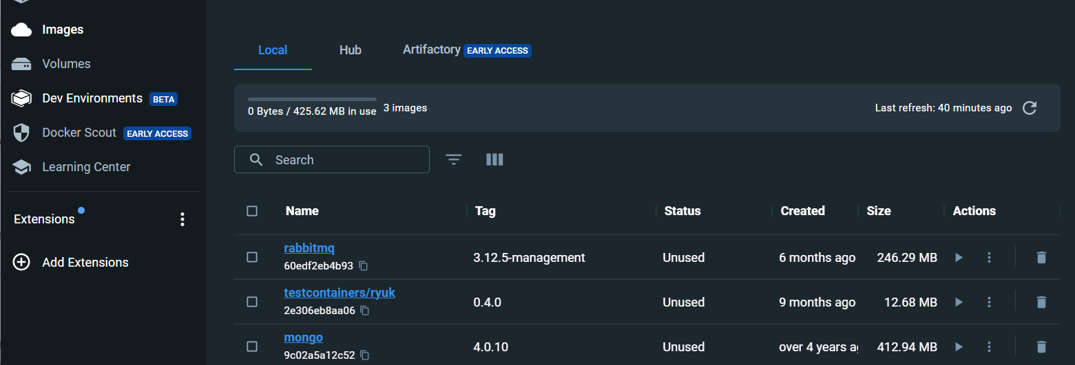

1. Run rabbitmq docker image: docker run --rm -it -p 15672:15672 -p 5672:5672 rabbitmq:3.12.10-management

By default, username and password are guest

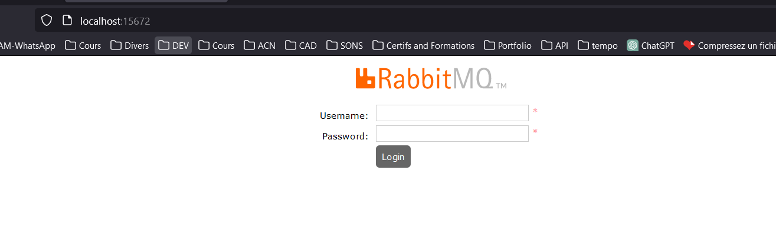

Once open go to:

* Exchanges->add new exchange and enter the name
* Queue and streams->add new queue and enter the name
* Open your new exchange and bing Exchange and Queue
* Exchanges->publish message, specify the Routing_key

### Connection between *Spring boot* and *RabbitMQ* server

1. Architecture

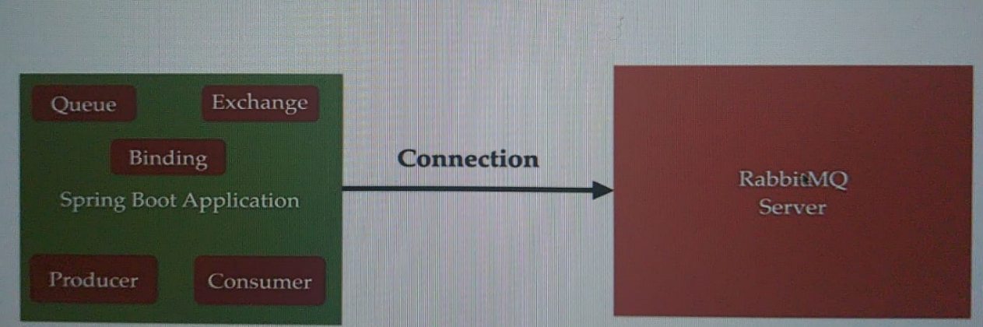

1. Spring boot autoconfiguration for Spring AMQP(RabbitMQ)

*#Connexion to rabbitmq server*spring:  
 rabbitmq:  
 host: localhost  
 port: 5672  
 username: guest  
 password: guest

1. Configure RabbitMQ in Spring Boot App.

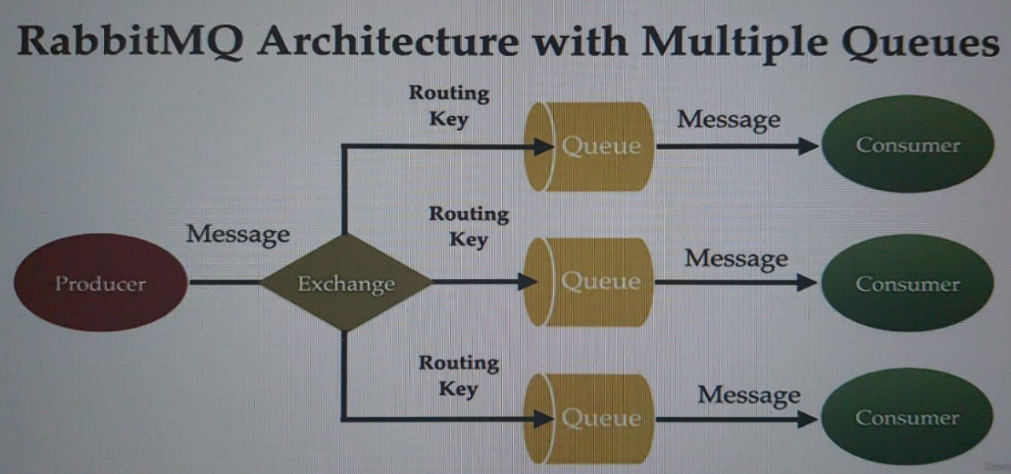

1. Configure rabbitMQ for JSON Message

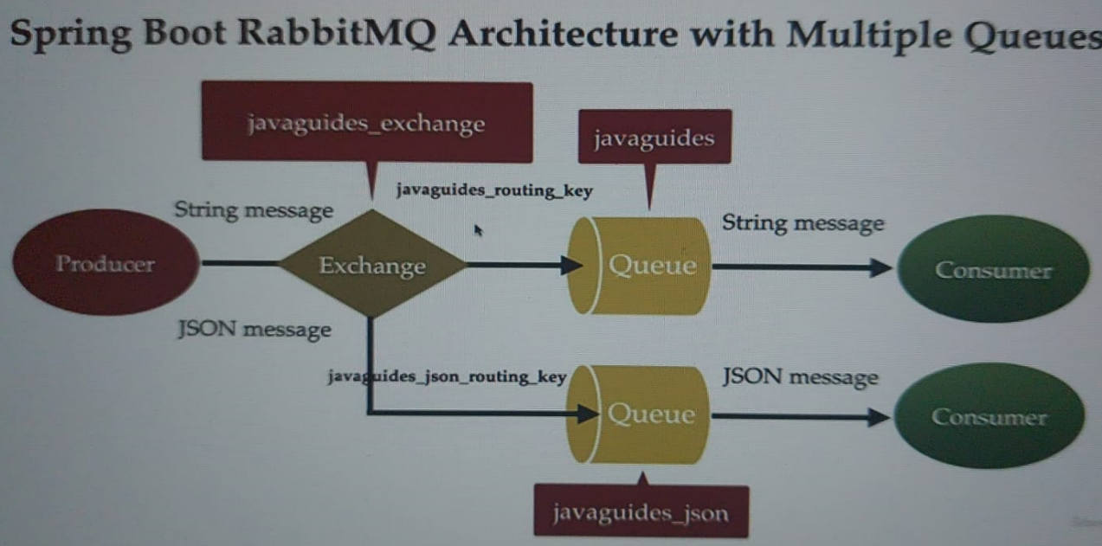

## Spring boot RabbitMQ Event-driven microservices architecture with multiple Queues

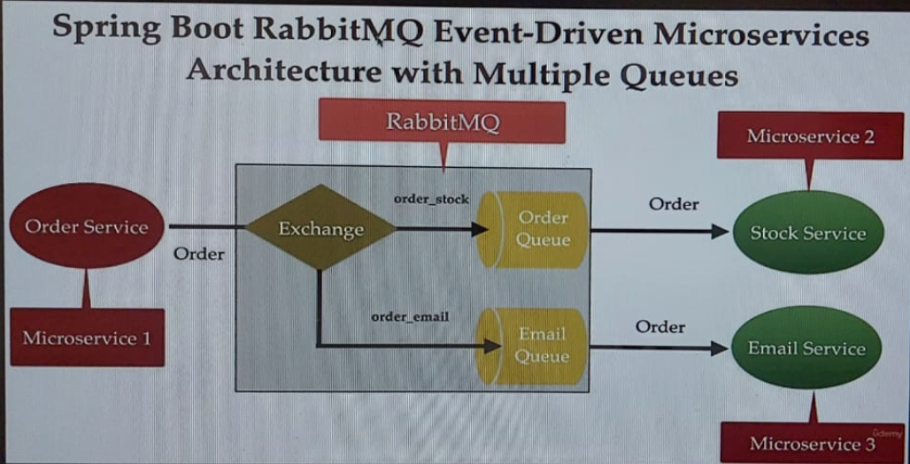

## Apache Kafka vs RabbitMQ: Make you choose

